Part 1. Protostomians species

Acyrthosiphon pisum
Pristionchus pacificus
Caenorhabditis elegans
Tetranychus urticae
Danaus plexippus
Stegodyphus mimosarum
Daphnia pulex
Drosophila melanogaster
Nasonia vitripennis
Zootermopsis nevadensis
Ixodes scapularis
Strigamia maritima
Helobdella robusta
Capitella teleta
Nematostella vectensis
Schistosoma mansoni
Megaselia scalaris
Trichinella spiralis
Solenopsis invicta
Lepeophtheirus salmonis
Lingula anatina
Adineta vaga
Lottia gigantea

Part 2 Phylogenetic tree

(((((((20chinese_turtle_NPPB:0.64242115,21xenopus_nppb:0.78105222)0.5789:0.10551734,19platypus_NPPB:1.06297592)0.2368:0.12323940,(12human_NPPA:0.65314115,13platypus_NPPA:0.48629313)1.0000:0.44872189)0.0526:0.12028517,('14painted turtle NPPA-201 peptide: ENSCPBP00000031300 pep:protein coding':0.86408056,18human_NPPB:0.85570541)0.4737:0.12133540)0.0000:0.07282121,(15zebrafish_nppa:1.09677797,((23human_NPPC:0.68433746,24opossum_NPPC:0.54102654)0.9474:0.30572990,(25painted_turtle_NPPC:0.75556487,26spotted_gar_nppc:0.80257975)0.4737:0.07548124)0.6579:0.27235036)0.1053:0.01076593)0.0000:0.13292647,(5Trichinella_sp:1.42462292,17hagfish_CNP:1.41955946)0.0263:0.10396069)0.0000:0.01338934,(22spotted_gar_nppb:0.98882021,((7Strongylocentrotus_purpuratus:1.43388645,8Acanthaster_planci2:1.27416375)0.3421:0.07113046,(10Ciona_intestinalis:1.19978360,(6Acanthaster_planci:1.22233320,11Oikopleura_dioica2:1.20808526)0.2895:0.06491759)0.1579:0.10863262)0.0789:0.05580469)0.0263:0.05587402,(3Neodiprion_lecontei:1.26791697,(4Varroa_jacobsoni:1.32591911,(9Oikopleura_dioica:1.21922749,16lamprey_CNP:1.43669365)0.1579:0.09639877)0.0263:0.08105920)0.0000:0.07157206);

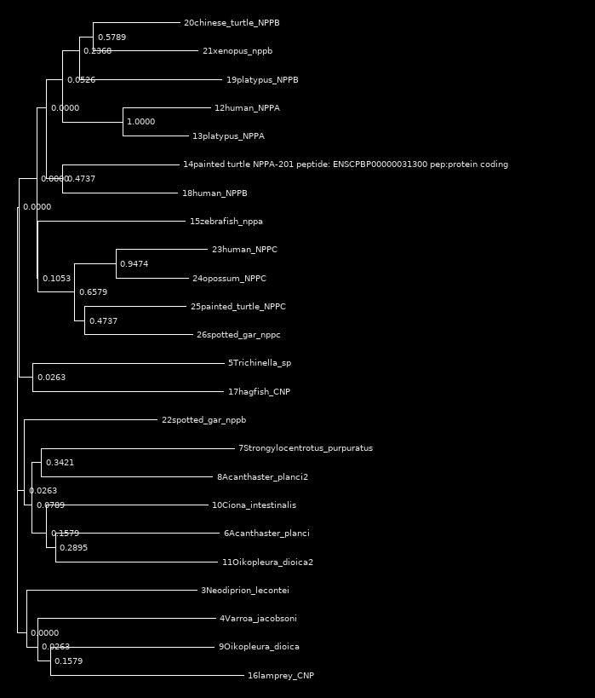

Results alignments

Lamprey cnp / Vollenhovia emeryi: id 19.1%, sim 36.1
Lamprey cnp / Brazilian scorpion 38.5%, 53.8%
Lamprey cnp / Neodiprion lecontei 20.3% 30.2%
Lamprey cnp / Varroa jacobsoni 23.9% 33.0%
Lamprey cnp / Trichinella sp 21.1% 31.7%
Lamprey cnp / Acanthaster planci 22.0% 32.6%
Lamprey cnp / Strongylocentrotus purpuratus 27.6% 39.7%
Lamprey cnp / Oikopleura dioica 20.4% 35.2%
Lamprey cnp / Ciona intestinalis 26.6% 34.4%

Part 3. Docking analysis

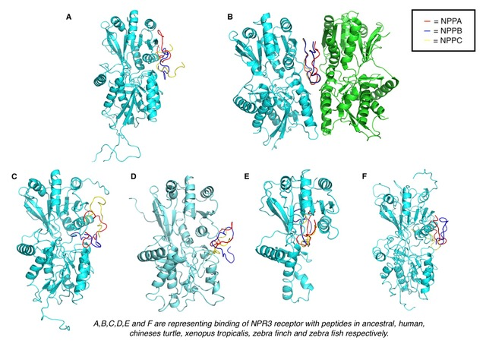

Part 4. Binding site in vertebrates

NPR3 in fishes

Position of the binding amino acids in the alignment: 125, 153, 160, 178, 179, 186, 219, 223, 229, 233, 236, 249.

 | % ID of the amino acids (with human) | % ID of the whole sequence (with human)
Zebrafish | 83% | 52.0%
Spotted gar | 83% | 57.9%
Tetraodon | 75% | 55.5%
Fugu | 83% | 56.0%

NPR1 in fishes

Position of the binding amino acids in the alignment: 114, 137, 140, 144, 160, 162, 169, 170, 204, 215, 216, 218, 219, 222, 223, 235

 | % ID of the amino acids (with human) | % ID of the whole sequence (with human)
Zebrafish | 31% | 61.8%
Spotted gar | 63% | 61.9%
Amazon molly | 44% | 59.3%
Platyfish | 44% | 57.5%

NPR3 in Coelacanthe

Position of the binding amino acids in the alignment: 110, 138, 145, 163, 164, 171, 204, 208, 215, 219, 222, 234. 92% ID

NPR1 in Coelacanthe

Position of the binding amino acids in the alignment: 99, 122, 25, 129, 145, 147, 153, 154, 188, 199, 200, 202, 203, 206, 207, 220. 75% ID

Part 5. BLAST analysis

Vollenhovia emeryi

BLAST result

Max Score | Total Score | Query Cover | E value | Per. Ident | Accession

 | 1415 | 1415 | 26% | 0.0 | 99.71%

Protein function: Elongation factor, enzyme

Neodiprion lecontei

BLAST result

Max Score | Total Score | Query Cover | E value | Per. Ident | Accession

 | 1526 | 1526 | 99% | 0.0 | 84.23% | XP_012256658.1

Protein function: RAS signaling antagonist

Varroa jacobsoni

BLAST result

Max Score | Total Score | Query Cover | E value | Per. Ident | Accession

58.5 | 58.5 | 89% | 1e-05 | 23.72% | XP_008474842.1

Protein function: homolog maelstrom protein

Trichinella sp
BLAST result

Max Score | Total Score | Query Cover | E value | Per. Ident | Accession

 | 106 | 106 | 18% | 5e-22 | 94.23% | KRY56513.1

Protein function: Enzyme, catalyse the conversion of RNA retro elements

Acanthaster planci

BLAST result

Max Score | Total Score | Query Cover | E value | Per. Ident | Accession

 | 155 | 155 | 25% | 2e-39 | 47.89% | PIK40037.1

Protein function: putative zinc finger CCHC domain-containing protein 3-like

Strongylocentrotus purpuratus

Uncharacterised

Oikopleura dioica

Uncharacterised

Ciona intestinalis

Protein function: Enzyme, regulation of cell survival

