Supplementary table 2: Clinical and demographic characteristics of the healthy controls who participated in the study.
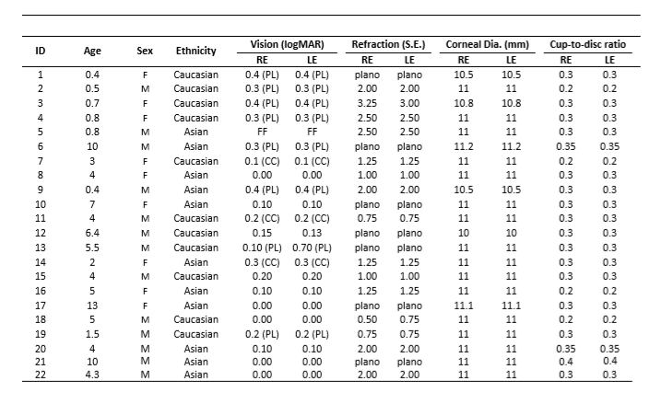

M=male, F=female; RE=right eye, S.E. = spherical equivalent; FF=following and fixing; PL= preferential looking; CC=Cardiff cards; in all other participants Kay pictures or Snellen test were used.

